|  |  |
| --- | --- |
| **Project Name** | **P-724824 - Invoices type A with text** |
| **Date** | 18/05/2020 |
| **Version** | 1.0 |
| **Author(s)** | Matias Maldonado |

|  |
| --- |
| **Table of Contents** |

1 Document History 2

Change History 2

Review Detail 2

n/a 2

Approval Detail 2

2 Solution Overview 3

Design Scope 3

Assumptions 3

Dependencies 3

Constraints 3

Prerequisites 3

Solution Components 4

3 Functional Design 4

System Functions 4

Configuraciones y mapeos 5

Overarching Business Rules/Functions 10

4 User Interface Design 10

User Interface Overview 10

Business Process Models 11

User/Task Matrix 11

Screen Definitions 11

Screen Navigation & Functions 11

Screen Wireframes 12

4.1.2 Funcionalidad de Payment / Invoice (para facturas) 12

4.1.3 FWD Code 16

5 Data Design 23

5.1.1 Static Data Design 29

5.1.2 Data Conversion & Cleansing 30

6 Report Design 31

Report Definitions 31

6.1.1 Report 1 31

7 Integration Design 33

Overview of Integrations 33

Data Flow 33

File Details 33

File Layout 33

8 Open Issues 34

9 Future Releases 34

10 Appendix 34

Glossary of Terms 34

Reference Documents 34

# Document History

## Change History

|  |  |  |  |
| --- | --- | --- | --- |
| Ver. | Date | Author | Summary of Changes |
| 1.0 | 18/05/2020 | Maldonado Matias | Inicial |

## Review Detail

## n/a

## Approval Detail

*This document requires approval from the following people:*

|  |  |  |  |
| --- | --- | --- | --- |
| Approver | Document Version | Approval Date | Embedded Approval Ema |
| Xxxx Xxxxxx | 1.0 |  |  |

# Solution Overview

## Design Scope

* + Poder identificar si Factura A, de Factura A con Leyenda en la carga de PAYDOM / DNOTEDOM / CNOTEDOM
  + Mandar de manera Identificados los Documentos a JDE
  + Solamente para Owners de Argentina. (configurable)

## Out of Scope

* Modificación de algún reporte en FTS.
* Cargar alguna Información Adicional de estos tipos.
* Realizar estos cambios en Boolmart (Malta) ya que no carga PAYDOM en FTS

## Assumptions

|  |  |  |  |
| --- | --- | --- | --- |
| # | Assumptions | Date | Status |
| 1 | Descriptas en el Proyect Charter |  |  |

## Dependencies

|  |  |  |  |
| --- | --- | --- | --- |
| # | Dependencies | Internal/External to Project | Responsible |

## Constraints

|  |  |  |
| --- | --- | --- |
| **#** | **Constraints** | **Implications** |

## Prerequisites

## Solution Components

# Functional Design

## System Functions

|  |  |  |  |  |  |
| --- | --- | --- | --- | --- | --- |
| **Function Name** | **Description** | **Requirements**  **Referenced** | **Pre-Condition** | **Trigger** | **Function**  **Process Steps** |
| Funcionalidad de Carga de Inv/Pmt | Indicar documento con Leyenda | FR001 - Modificar Pantalla de Inv/Pmt | n/a | n/a |  |
| Envio Interface | Modificacion de Interfase de Argentina | FR002 - Modificar Interfase de AP | n/a | n/a |  |
|  |  |  |  |  |  |
|  |  |  |  |  |  |
|  |  |  |  |
|  |  |  |  |
|  |  |  |  |
|  |  |  |  |
|  |  |  |  |
|  |  |  |  |  |  |
|  |  |  |  |
|  |  |  |  |
|  |  |  |  |
|  |  |  |  |
|  |  |  |  |
|  |  |  |  |
|  |  |  |  |  |  |
|  |  |  |  |  |  |
|  |  |  |  |  |  |

## Overarching Business Rules/Functions

|  |  |  |  |  |  |  |
| --- | --- | --- | --- | --- | --- | --- |
| **ID** | **Business Rule Name** | **Business Driver** | **Condition** | **Rule** | **Type** | **Referenced Requirements** |
|  |  |  |  |  |  |  |

# User Interface Design

## User Interface Overview

## Business Process Models

*n/a*

## User/Task Matrix

|  |  |  |  |  |  |
| --- | --- | --- | --- | --- | --- |
|  |  |  |  |  |  |
|  |  |  |  |  |  |
|  |  |  |  |  |  |
|  |  |  |  |  |  |
|  |  |  |  |  |  |
|  |  |  |  |  |  |

## Screen Definitions

## Screen Navigation & Functions

#### Navigation

##### Menus

#### Functions

##### Objects

## Screen Wireframes

### Funcionalidad de Modificar Pantalla de Pmt /Inv

**Screen Purpose**

Modificar pantalla de Pmt/Inv para poder diferencias Documentos con Leyenda. BU APB

**Requirements Referenced**

**Screen Wireframe**

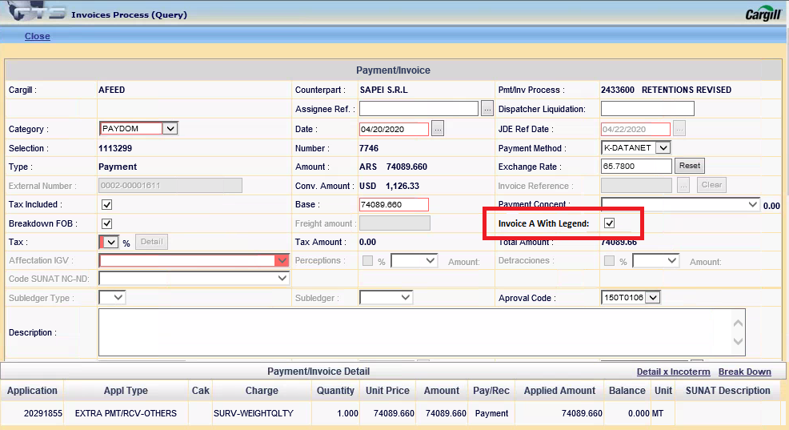

**Description**

Para cuando se cargue un documento en la BU APB y el OWNER se Argentina para cuando se cargan los Documentos PAYDOM se deberá indicar si el mismo contiene leyenda o no.

Únicamente esta Opcion se verá para la Category PAYDOM / DNOTEDOM / CNOTEDOM

Datalle: Doc. A with Legend:

También será visible en las vista tipo:

* Add
* Delete
* Modify
* Query

Cuando la opción este seleccionada debe guardar una “L”, en caso contrario vacío, por default y cada vez que se cambia la category debe ser vacío.

Modificar aspx (Invoice_Payment_Process_ML)

Crear FWD_CODE para agregar OWNERS y Tipo de Categoria (PAYDOM / DNOTEDOM / CNOTEDOM)

Con esto validar cuando mostrar y cuando no.

PL

Agregar columna a Tabla Payment_Invoice

Modificar SP de PX, PI y PU

Revisar cuales hacen el Get de la Data y Update en Action

### Funcionalidad de Modificación Interface AP - Argentina

**Screen Purpose**

Se debe enviar información solicitada como indica JDE

**Requirements Referenced**

**Screen Wireframe**

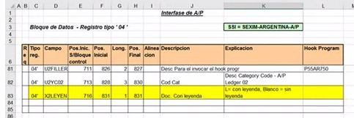

**Description**

Se debe agregar campo correspondiente a Invoice con Leyenda para que JDE pueda procesar estos documentos,

Según solicitado el campos es el X2LEYEN que está en la última posición de la interface para Argentina

Se debe mandar una L si es con leyenda en caso contratio, un espacio en blanco.

PL

Modifcar Package:

-

Se debe agregar a Query que generar que va a generar el cursor el campo creado en el anterior punto.

Para luego ser agregado al final de la interfase.

Esto solo tiene que ser para la parte que contenga 04

Tambien se debe incrementar el ciclo for con el nuevo tamaño del array que recorre para generar la línea a mandar a JDE.

Para Prueba Region 51 y BU 41

Interface GX_AP_GL_ARG







En los 09 agregar columna, solamente para no tener problema en Union

Crear el array

v_reg(82) para asginar este valor.

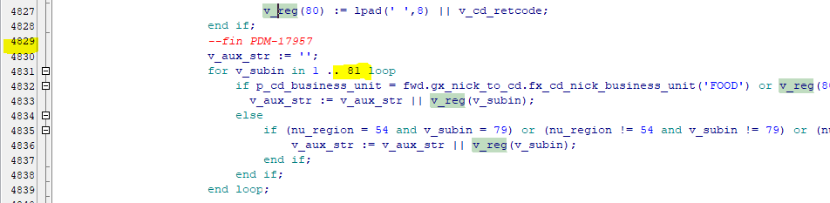

### Static Data Design

*This section includes the detailed design of the system’s static data. Static data (also known as system data) is information the system needs for proper operation. This includes all lookup table data, system parameters, and may include such things as business rule information. Include the name of static data table and fields within the table*

|  |  |  |
| --- | --- | --- |
| **Source** | **Static Table Name** | **Static Data Fields** |
| *List source of static data.* | *Name of table housing static data* | *Fields in static table.* |
|  |  |  |
|  |  |  |
|  |  |  |
|  |  |  |
|  |  |  |
|  |  |  |

### Data Conversion & Cleansing

*Describe the strategy and requirements for the data conversion, if applicable. This section serves as an introduction to what is required for the data conversion and is not designed to comprehensively detail the data conversion (i.e. field mapping).*

|  |  |  |  |
| --- | --- | --- | --- |
| **Legacy Systems** | **Summary** | **Conversion Method** | **Data Conversion Date** |
| *List legacy systems requiring data conversion.* | *Include a summary of the type of data to be cleansed or converted.* | *Outline conversion method (i.e. code, use of data warehouse, temp database, or business rules, etc.)* | *List conversion date needed.* |
|  |  |  |  |
|  |  |  |  |
|  |  |  |  |
|  |  |  |  |
|  |  |  |  |
|  |  |  |  |
|  |  |  |  |
|  |  |  |  |

# Report Design

*If reports are defined in another document, reference document link here; otherwise define reports below. Delete section if there are no reports.*

## Report Definitions

|  |  |  |
| --- | --- | --- |
| **Report Package:** *Group like reports together by function or user group.* | | |
| **Report Name** | **Purpose & Users** | **Usage** |
| *Report Name* | *Describe business purpose or benefit..* | *Specify number of users of report and their roles, indicate report frequency(i.e. daily, weekly, monthly)* |
|  |  |  |
|  |  |  |
|  |  |  |
|  |  |  |

### Report 1

*Attach report mock up. Include one section per report.*

**Report Mock Up**

*Complete table and embed report mock up Alternately, you could embed excel file with both a mock up and the detailed report specification fields and data elements.*

| **Report Name** | **Specification** | **Details** |
| --- | --- | --- |
| Report1 | Data Domain | *Define the type of data present in the report (i.e customer data, invoice data).* |
| Associated Reports | *Note if report is based on another existing report or leverages similar data as another existing report* |
| Scope | *Provide a brief description of the scope of this Information Space (e.g., limited to a single instance/region?). Describe items that are outside the scope of this design.* |
| Data Source | *Indicate source of report data.Include source system and source table.* |
| Instance Variation | *If an instance variation exists, provide a summary of how the difference in the instance will need to be taken into account for the report.* |
| Assumptions | *Describe any assumptions that have been made in the process of completing this design.* |
| Data Load Frequency | *Frequency of data load & process/time dependencies.* |
| Report Type | *Specify report type (i.e. canned, ad-hoc, dashboard, interactive)* |
| Pre-Conditions | *Note any conditions which must be satisfied before report can be generated* |
| Special Security | *Detail design for security of the report.*  *Do certain users of the report need more interactive capabilities than other users?*  *Note any data restrictions, data classification, or data privacy impacts for report data.* |
| Parameters | *Define report parameters (i.e. By Platform, By BU, By Geograpy, Data Range).* |
| Viewer Optimization | *Web Optimized or Print Optimized* |
| Print Size | *8.5 x 11, Legal, Other* |
| Report Orientation | *Portrait or Landscape* |
| Interactive Capabilities | *Specify all required drill-down/interactive functionality.* |
| Distribution | *What is preference for report delivery (i.e. run on demand, emailed)* |
| Comments |  |

**Report Data Elements**

*For changes to existing reports define changes to report instead of all fields.*

| **Element Name** | **Specification** | **Details** |
| --- | --- | --- |
| Element Name1 | Description |  |
| Field Type |  |
| Format |  |
| Data Source |  |
| Aggregation |  |
| Formula |  |
| Calculation |  |
| Field Length |  |
| Rounding |  |
| Comments |  |
| Element Name2 | Description |  |
| Field Type |  |
| Format |  |
| Data Source |  |
| Aggregation |  |
| Formula |  |
| Calculation |  |
| Field Length |  |
| Rounding |  |
| Comments |  |
| Element Name3 | Description |  |
| Field Type |  |
| Format |  |
| Data Source |  |
| Aggregation |  |
| Formula |  |
| Calculation |  |
| Field Length |  |
| Rounding |  |
| Comments |  |
| Element Name4 | Description |  |
| Field Type |  |
| Format |  |
| Data Source |  |
| Aggregation |  |
| Formula |  |
| Calculation |  |
| Field Length |  |
| Rounding |  |
| Comments |  |
| Element Name5 | Description |  |
| Field Type |  |
| Format |  |
| Data Source |  |
| Aggregation |  |
| Formula |  |
| Calculation |  |
| Field Length |  |
| Rounding |  |
| Comments |  |

# Integration Design

*If integration is defined in another document, please link to that document here; otherwise define integrations in sections 7.1-7.3 below. For additional guidance on functional design for integrations, please consult the Integration Process Wiki:*

## Overview of Integrations

*Describe the scope of the solution integrations.*

## Data Flow

*Attach díagram of solution integration solution*.

## File Details

|  |  |
| --- | --- |
| File Name |  |
| File Name |  |
| File Destination |  |
| File Transfer Method |  |
| Type of Data in File |  |
| Frequency |  |
| Time |  |
| Business Rules or Translations to be applied |  |

## File Layout

*Use the table to define incoming and outgoing file layouts. File location is the attribute’s position in the file.*

| File Location | Field Name | Data Example | File  Location | Field Name | Translation Rule |
| --- | --- | --- | --- | --- | --- |
|  |  |  | 1 |  |  |
|  |  |  | 2 |  |  |
|  |  |  | 3 |  |  |
|  |  |  | 4 |  |  |
|  |  |  | 5 |  |  |
|  |  |  | 6 |  |  |
|  |  |  | 7 |  |  |
|  |  |  | 8 |  |  |
|  |  |  | 9 |  |  |
|  |  |  | 10 |  |  |

# Open Issues

*Use the table during design discussions to track open issues Assumptions identified earlier in this document should be tracked as open issues until resolved.*

| **Status** | **Date** | **Issue** | **Reported By** | **Comments** |
| --- | --- | --- | --- | --- |
|  |  |  |  |  |
|  |  |  |  |  |
|  |  |  |  |  |
|  |  |  |  |  |
|  |  |  |  |  |

# Future Releases

*Use the table to track enhancements or functionality to be considered for future releases.*

| **Date** | **Description** | **Reported By** | **Comments** |
| --- | --- | --- | --- |
|  |  |  |  |
|  |  |  |  |
|  |  |  |  |
|  |  |  |  |
|  |  |  |  |

# Appendix

## Glossary of Terms

| **Acronym / Term** | **Definition** |
| --- | --- |
|  |  |
|  |  |
|  |  |
|  |  |
|  |  |
|  |  |
|  |  |
|  |  |
|  |  |
|  |  |

## Reference Documents

| **Name** | **Location / Link / Attachment** |
| --- | --- |
|  |  |
|  |  |
|  |  |
|  |  |
|  |  |